Kafka vs RabbitMQ 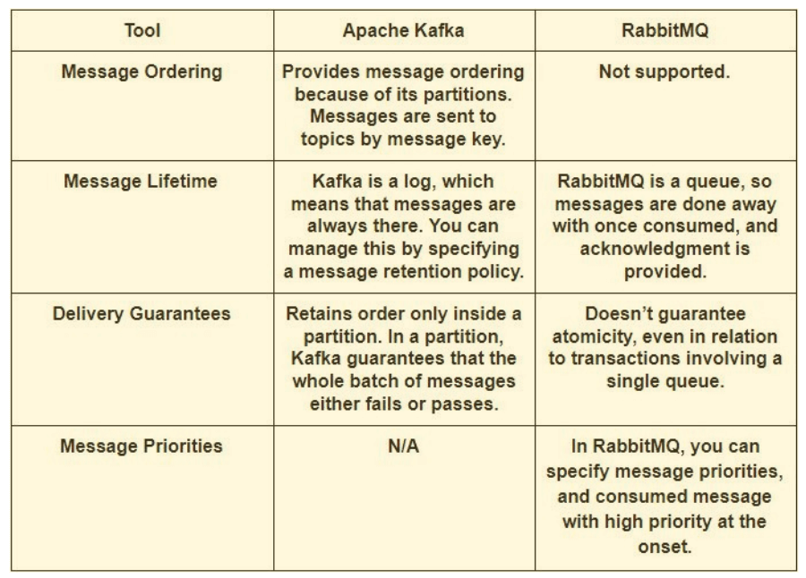

Kafka vs RabbitMQ Performance

Apache Kafka:
Kafka offers much higher performance than message brokers like RabbitMQ. It uses sequential disk I/O to boost performance, making it a suitable option for implementing queues. It can achieve high throughput (millions of messages per second) with limited resources, a necessity for big data use cases.

RabbitMQ:
RabbitMQ can also process a million messages per second but requires more resources (around 30 nodes). You can use RabbitMQ for many of the same use cases as Kafka, but you’ll need to combine it with other tools like Apache Cassandra.

